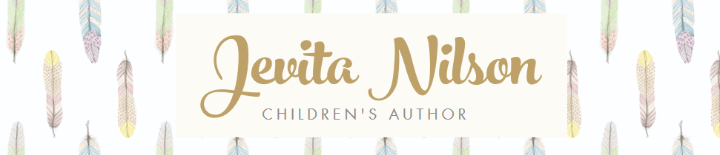
Jevita Nilson – Author Bio
​Jevita Nilson is a children's author from Perth, Western Australia. She has an undergraduate degree in Psychology and a post-graduate degree in Human Resources and currently juggles part-time work as an Organisational Development Consultant in the WA Public Sector, writing children’s books and looking after her two young children.
Her passion for reading and writing came from her mother, a primary school teacher with a love of literature. Books were always a central part of her childhood and she fondly remembers listening to her mother read books and poetry in her eloquent teacher’s voice.
It was the death of her mother in 2018 that saw Jevita rediscover her love of writing. She was inspired to write a children’s book to help young children understand the passing of a loved one. Her debut children’s picture book, Happy Hearts was published in August 2020 by New Holland Publishers. Happy Hearts uses an exciting adventure to explore the concepts of bereavement and the afterlife in a sensitive, original and magical way, whilst touching on the range of emotions when a loved one passes away.
Jevita has a passion for writing meaningful and uplifting stories for young children and her stories often touch on the difficult emotions and events a child may experience while growing up. Her main aim as a writer is to encourage readers to use their imagination and feel empowered through reading.
Jevita is an active member of the Society of Children's Book Writers and Illustrators (SCBWI), the Children's Book Council of Australia (CBCA) and has completed the Scribbles Creative Writing Course.
When she’s not writing, Jevita can be found practising Yoga, outside in nature with camera in hand or with her nose buried in a book.

Jevita Nilson – Children’s Author
Contact: jevita_nilson@hotmail.com
For more information and resources, visit: www.jevitanilson.com

